Unified Project Portfolio
Power BI | Power Apps | Excel | ETL | AWS
A showcase of dashboards, workflow automation, analytics, and data engineering projects.

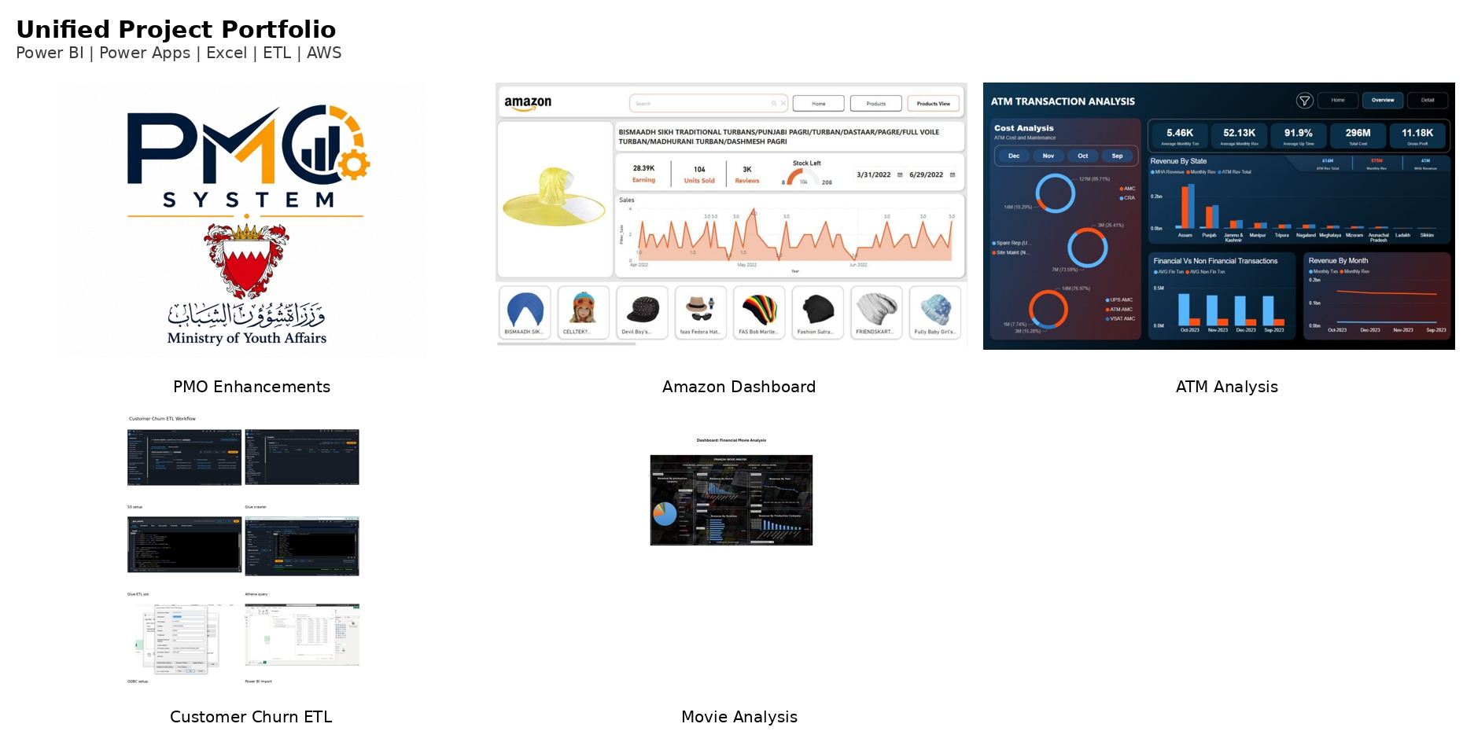

Portfolio at a glance
This portfolio combines five projects that show end-to-end capability in business reporting, low-code app development, Excel-based analysis, and cloud ETL automation.
Project | Platform | Focus | Outcome
PMO Enhancements | Power Apps / Automate / SharePoint / Power BI | Project requests, approvals, milestones, docs | Centralized governance and traceability
Amazon Dashboard | Power BI | Retail sales and product performance | Interactive KPI and category reporting
ATM Transactions Analysis | Power BI | Transaction, revenue, and location analysis | Operational visibility for banking metrics
Customer Churn ETL | AWS Glue / Athena / Airflow / Power BI | Automated data pipeline | Serverless analytics workflow
Financial Movie Analysis | Excel / Power Query | Movie revenue, budget, ROI analysis | Data-driven investment insights

Core capabilities demonstrated
- Dashboard design and storytelling for business stakeholders.
- Low-code process automation with approvals, notifications, and role-based access.
- Data preparation and transformation using Power Query and AWS ETL tools.
- Operational analytics with KPI tracking, drill-down views, and executive reporting.

1. PMO Enhancements
Ministry of Youth Affairs | Power Platform Solution
This low-code platform replaces spreadsheet tracking and manual follow-ups with a structured project governance workflow. Requests move through staged approvals, approved work becomes trackable projects, and the PMO team can monitor KPIs, milestones, documents, and reporting from one system.
- Built with Power Apps, Power Automate, SharePoint Lists, and Power BI.
- Supports Manager -> Chief -> Director approval flow with notifications.
- Covers request submission, project creation, milestone updates, documents, and executive reporting.
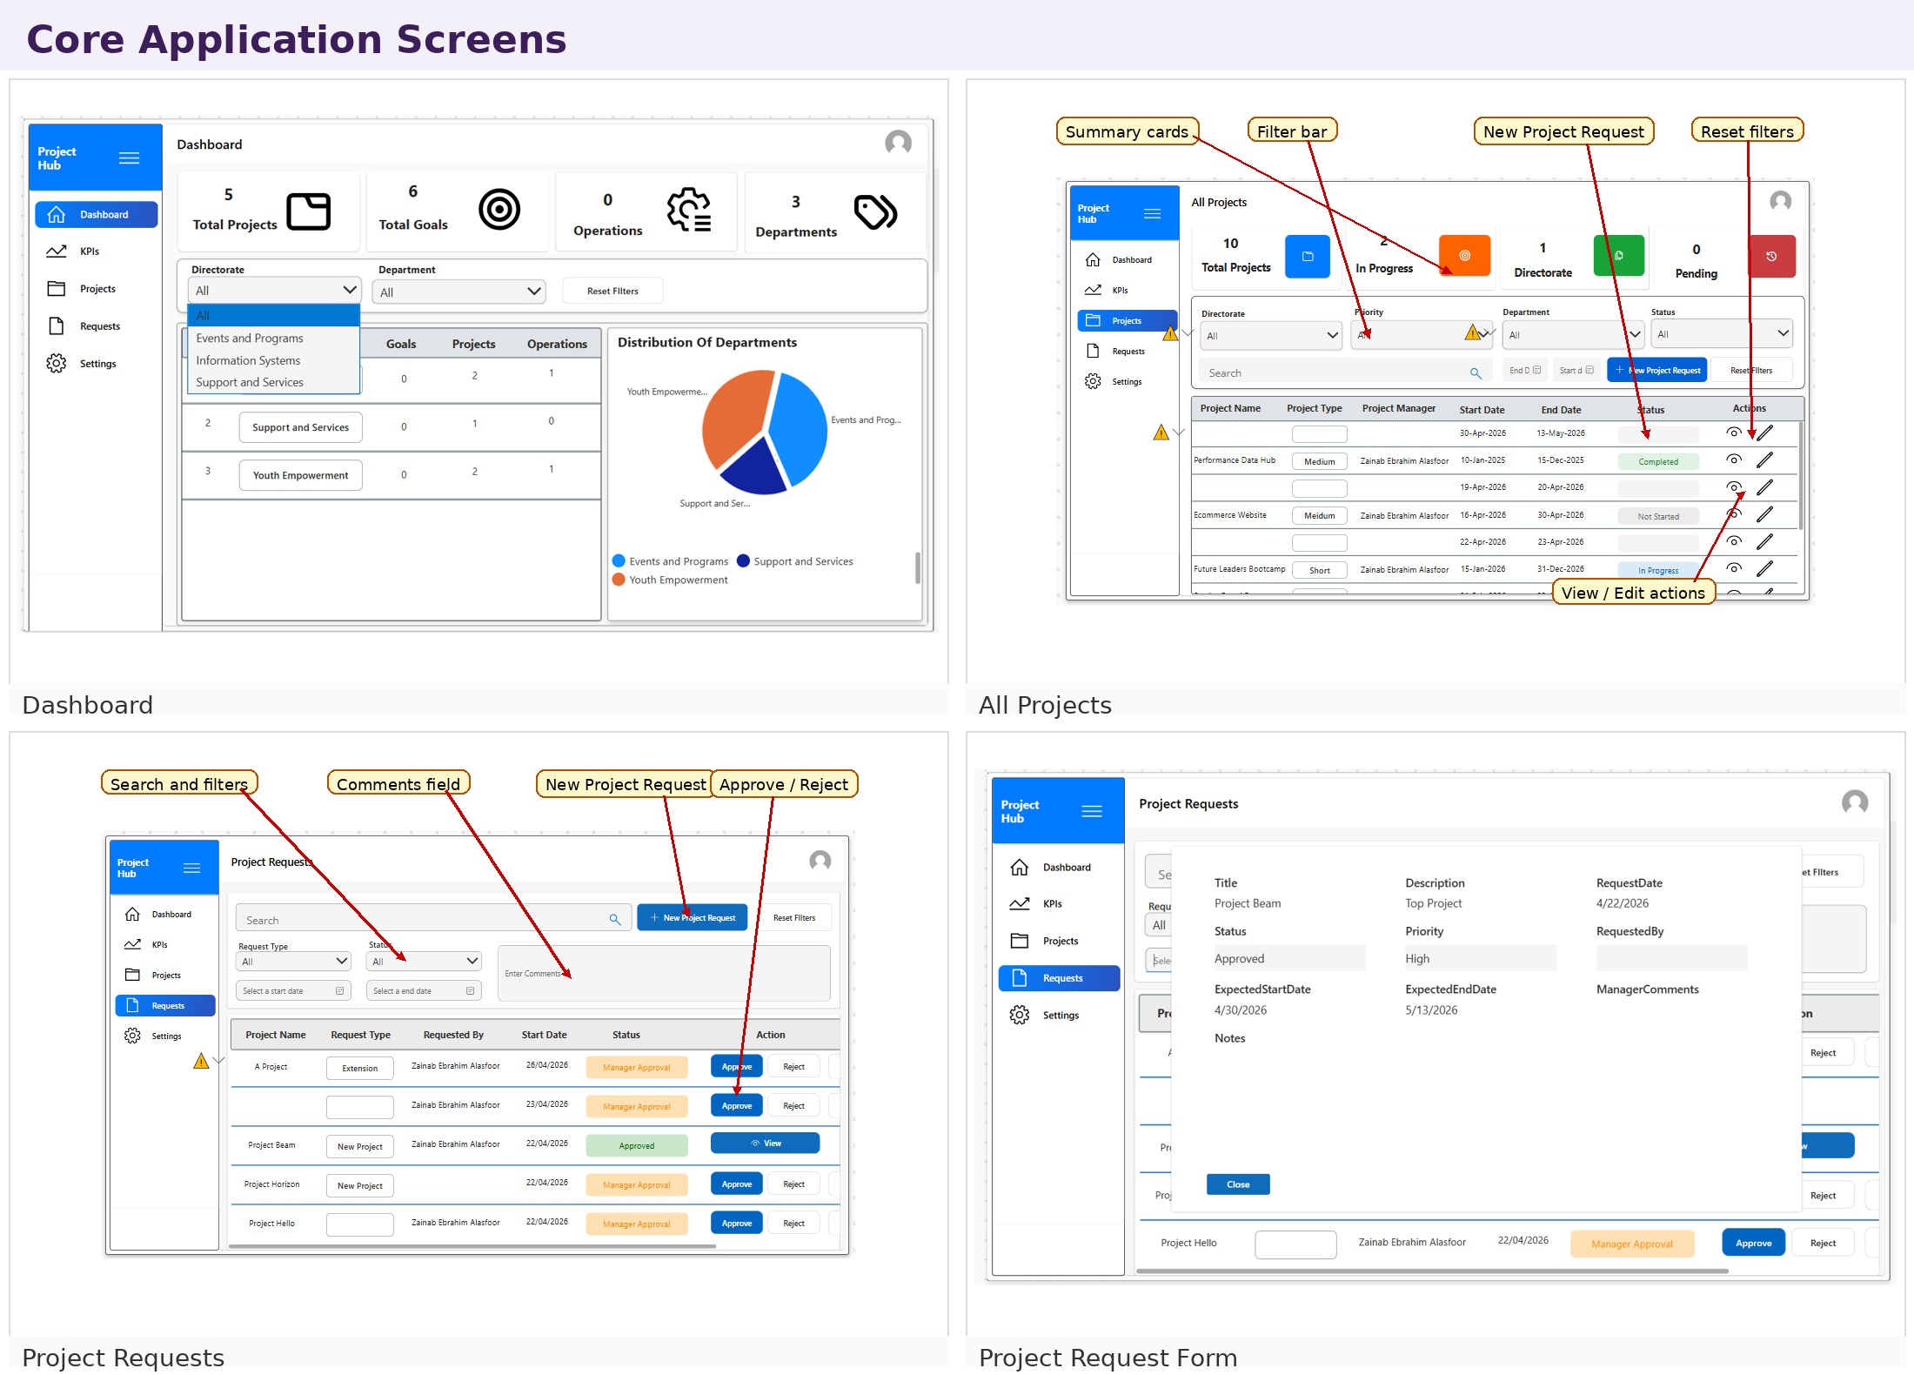  Core application screens | 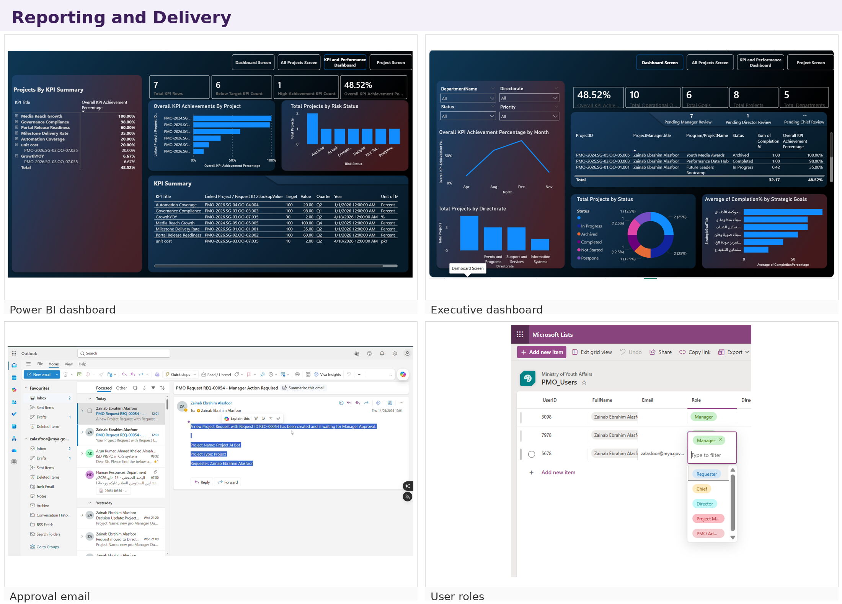  Reporting and delivery views

2. Amazon Dashboard
Power BI retail analytics
An interactive retail dashboard for product and sales analysis. The layout highlights category browsing, product performance, and summary trends so stakeholders can move from overview to detail quickly.
- Designed to present sales and product performance in a clean, executive-friendly layout.
- Highlights category-level browsing and product-level comparison.
- Useful for quick review of trends, stock signals, and product performance.
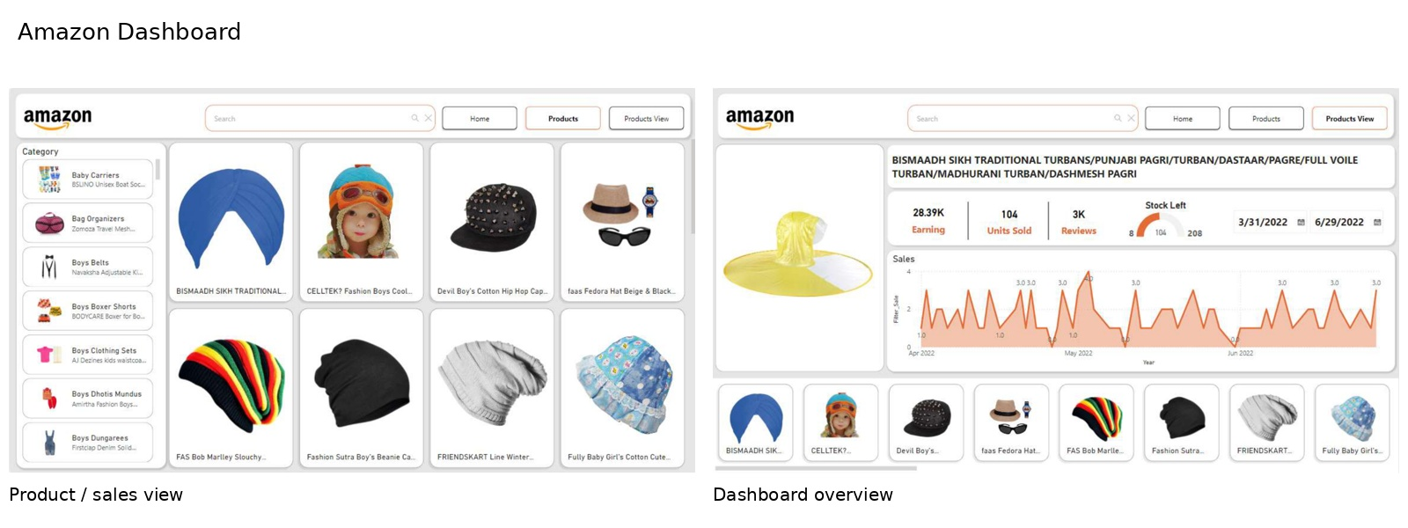

3. ATM Transactions Analysis Dashboard
Power BI banking operations dashboard
This dashboard summarizes ATM performance through cost analysis, revenue trends, transaction patterns, and regional comparisons. It supports monitoring of operational health and financial performance in a single view.
- Shows monthly KPIs, revenue by state, and transaction mix analysis.
- Compares financial and non-financial transactions to surface operational behavior.
- Provides a detailed drill-down page for granular transaction analysis.
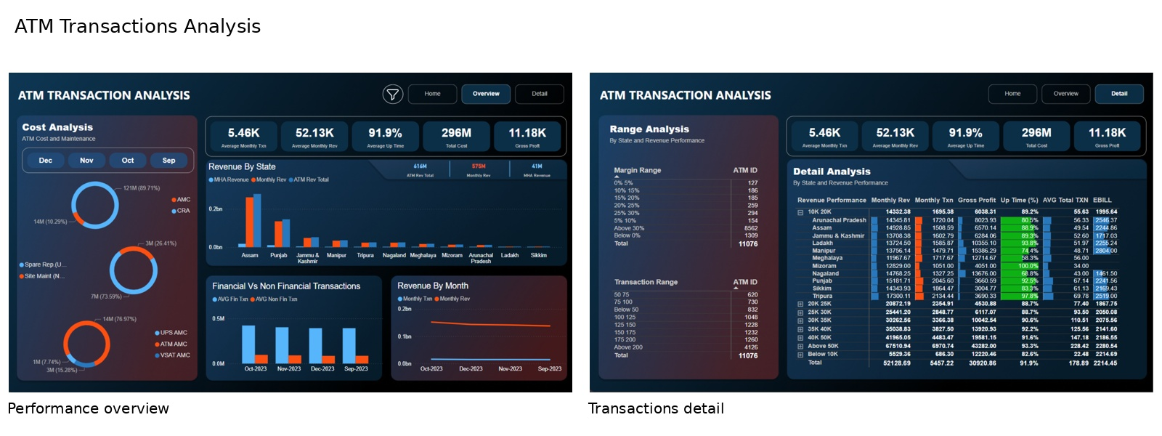

4. Customer Churn ETL Report
AWS Glue | Athena | Airflow | Power BI
This project demonstrates a serverless analytics pipeline. Raw data is stored in S3, cataloged with Glue Crawler, transformed with Glue ETL, queried in Athena, and consumed in Power BI through ODBC. Airflow automates the flow from ingestion to refresh.
- Raw, processed, and query-result buckets are organized in S3.
- Glue crawler and ETL jobs prepare clean, query-ready data.
- Athena and Power BI provide the reporting layer, with Airflow for orchestration.
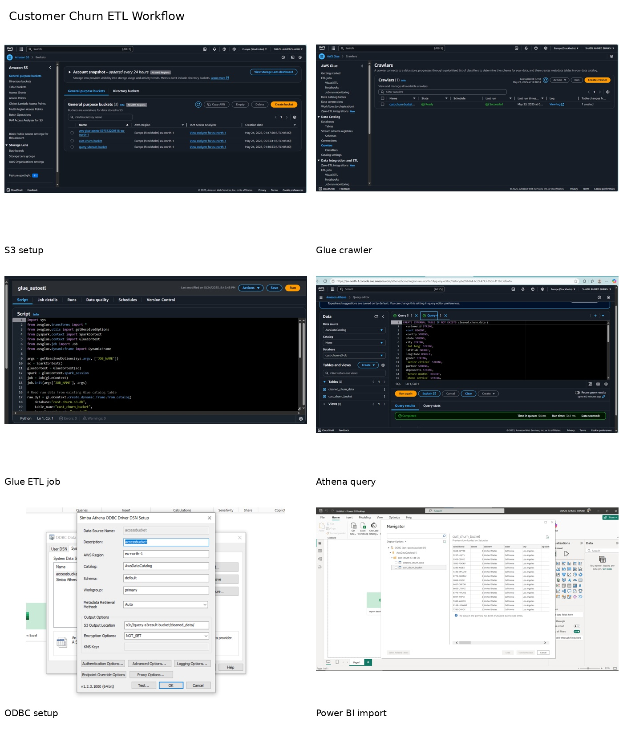

5. Financial Movie Analysis using Excel
Excel | Power Query | Pivot Tables | Charts
This analysis merges IMDb and TMDb data into a single master dataset, then uses Power Query and Excel visuals to study revenue, budget, ROI, genres, countries, runtime, and rating patterns.
- Unified multiple datasets into a single analytical model.
- Calculated ROI and explored performance by genre, country, runtime, and release year.
- Identified strong budget-revenue relationships and high-ROI cases.
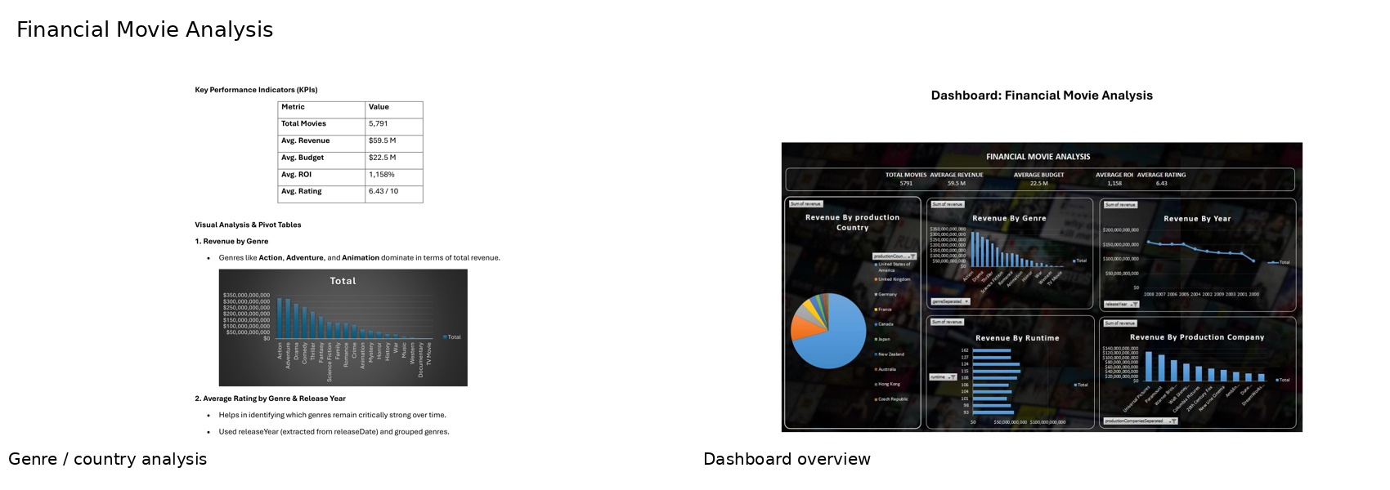
Closing summary
Together, these projects show a practical mix of dashboarding, workflow automation, cloud ETL, and spreadsheet-based analytics. The portfolio is intentionally concise and image-led so it can be used for showcasing, submission, or interviews.

